**3.REACTJS-HQL**

**FOLDER STRUCTURE**

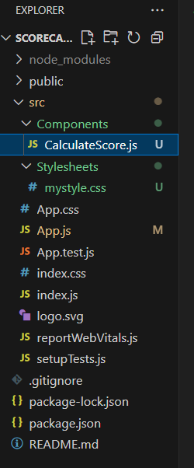

**CalculateScore.js**

import React from 'react';

import '../Stylesheets/mystyle.css';

function CalculateScore() {

  const name = "Krish";

  const school = "Greenwood High School";

  const total = 475;

  const goal = 500;

  const average = (total / goal) * 100;

  return (

    <div className="score-container">

      <h2>Student Score Summary</h2>

      <p><strong>Name:</strong> {name}</p>

      <p><strong>School:</strong> {school}</p>

      <p><strong>Total Marks:</strong> {total}</p>

      <p><strong>Goal Marks:</strong> {goal}</p>

      <p><strong>Average Score:</strong> {average.toFixed(2)}%</p>

    </div>

  );

}

export default CalculateScore;

**mystyle.css**

.score-container {

  margin: 30px;

  padding: 20px;

  border: 2px solid #4CAF50;

  border-radius: 10px;

  background-color: #f9f9f9;

  font-family: Arial, sans-serif;

}

.score-container h2 {

  color: #4CAF50;

}

.score-container p {

  font-size: 18px;

  margin: 5px 0;

}

**App.js**

import React from 'react';

import './App.css';

import CalculateScore from './Components/CalculateScore';

function App() {

  return (

    <div className="App">

      <CalculateScore />

    </div>

  );

}

export default App;

**OUTPUT**

